**Pre-Request script and Test script Execution order**

Generally, Test (post request script) will be executed after the request only🡪 so test is post-request

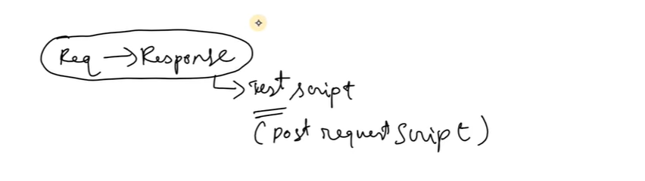

If we want our test to be executed before the actual request, then we should write 🡪 pre- request / Pre-Request script

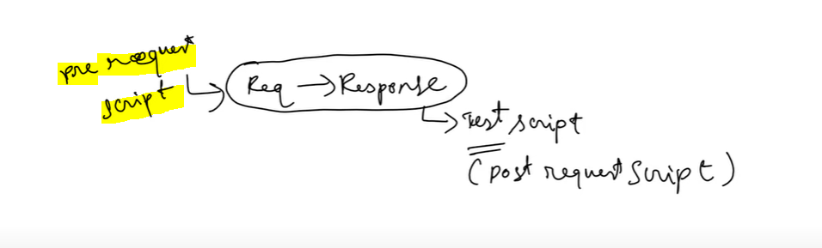

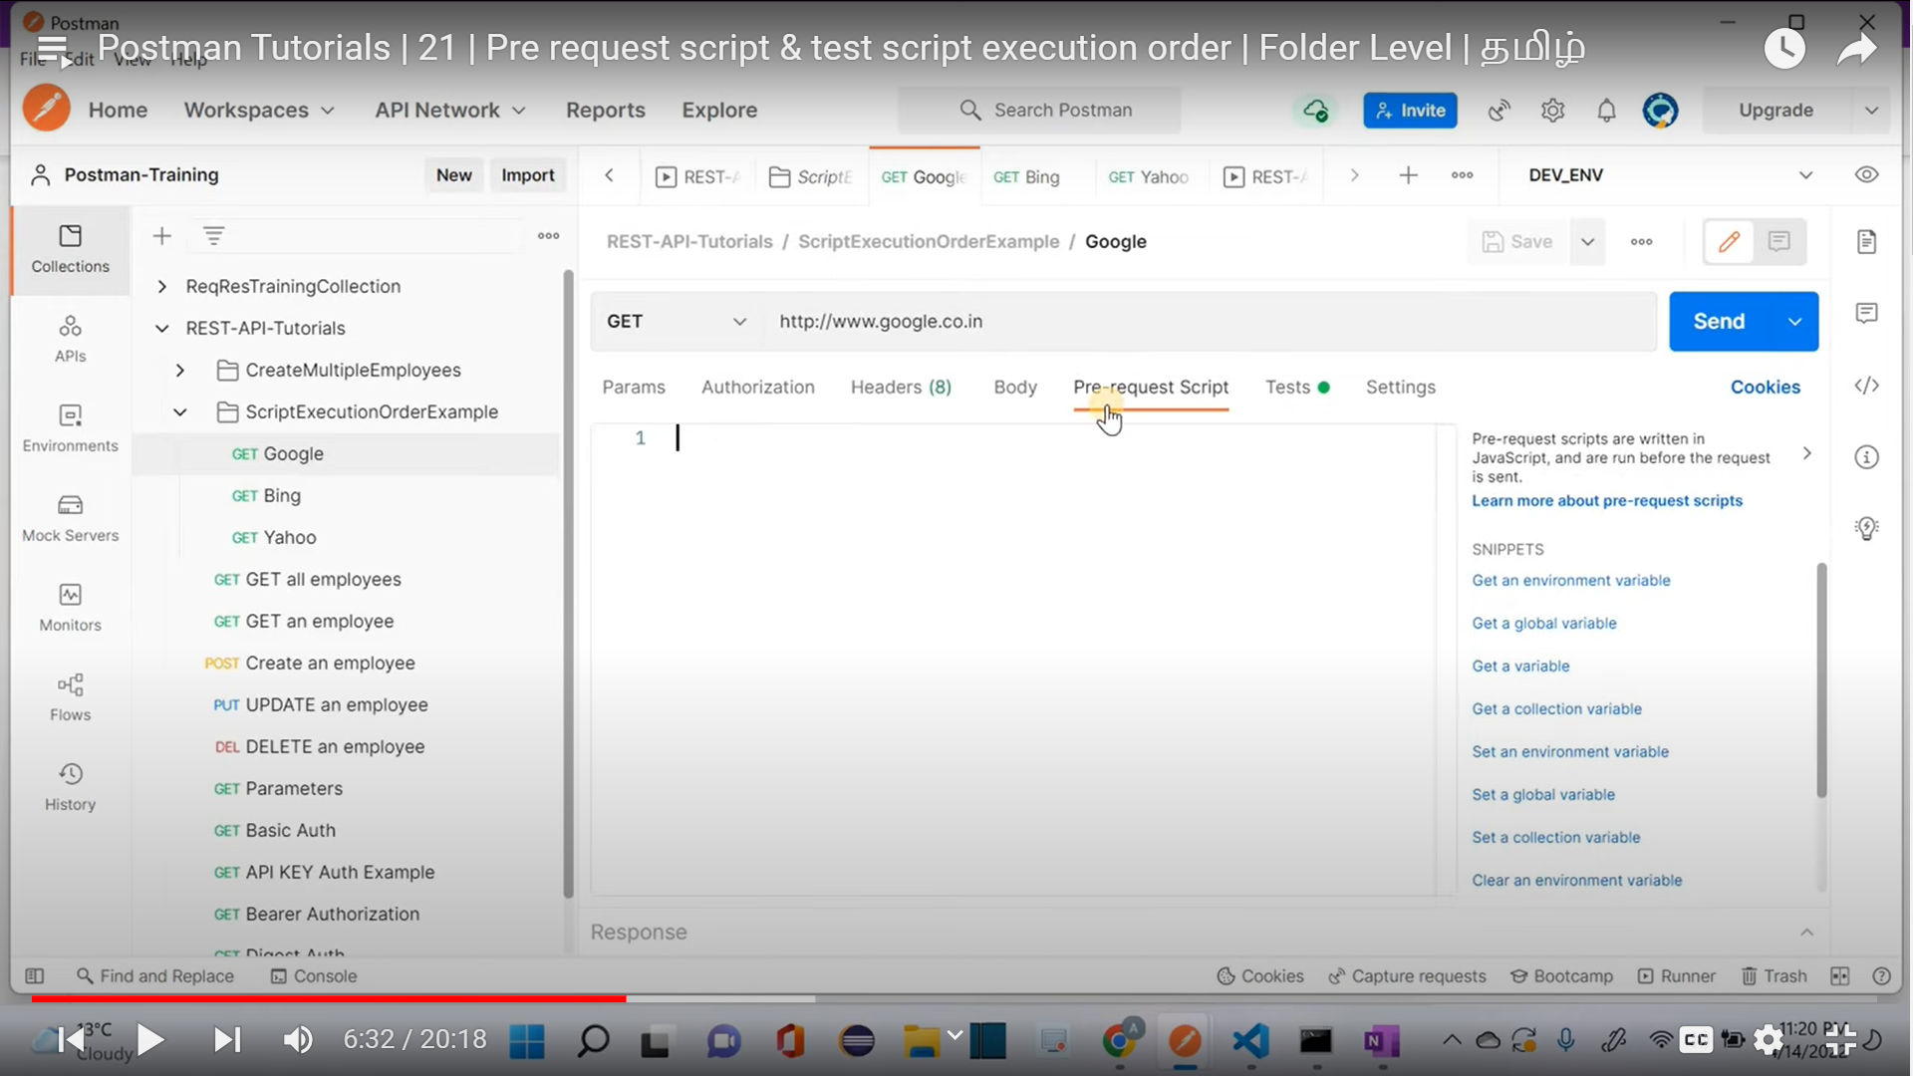

**Order of execution🡪**

Pre-Request scripts

actual requests

post-request scripts

**Folder Level Pre-Request Script**

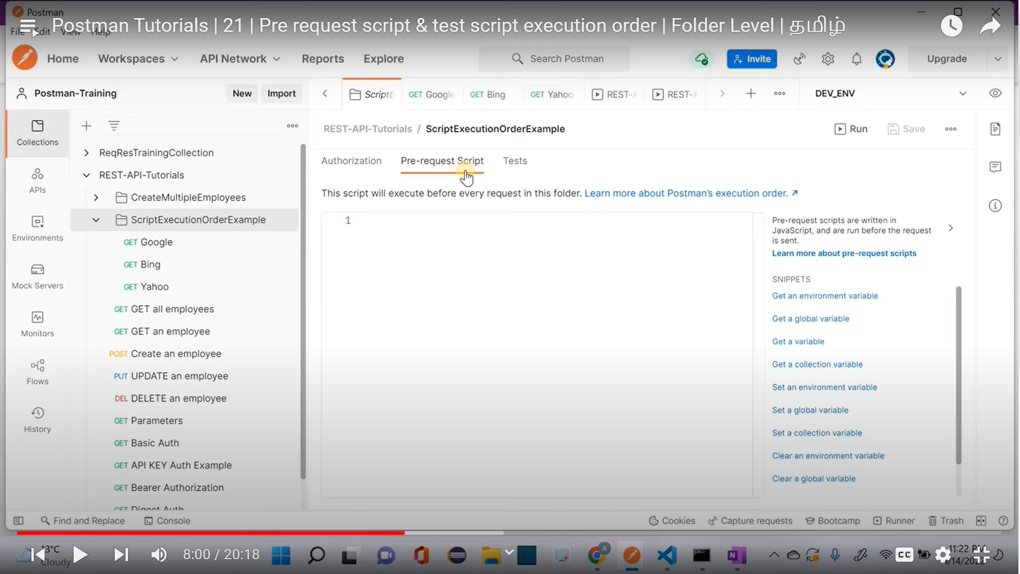

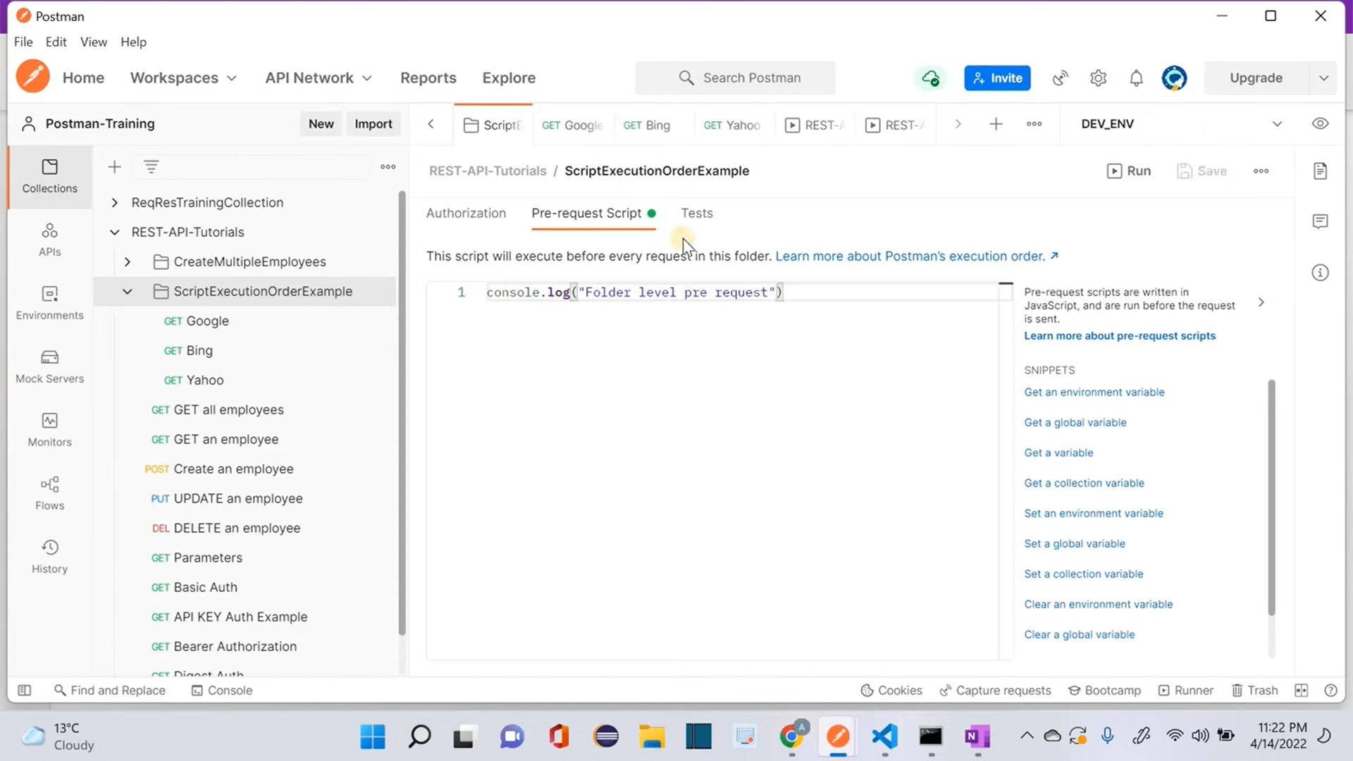

**Folder level test**

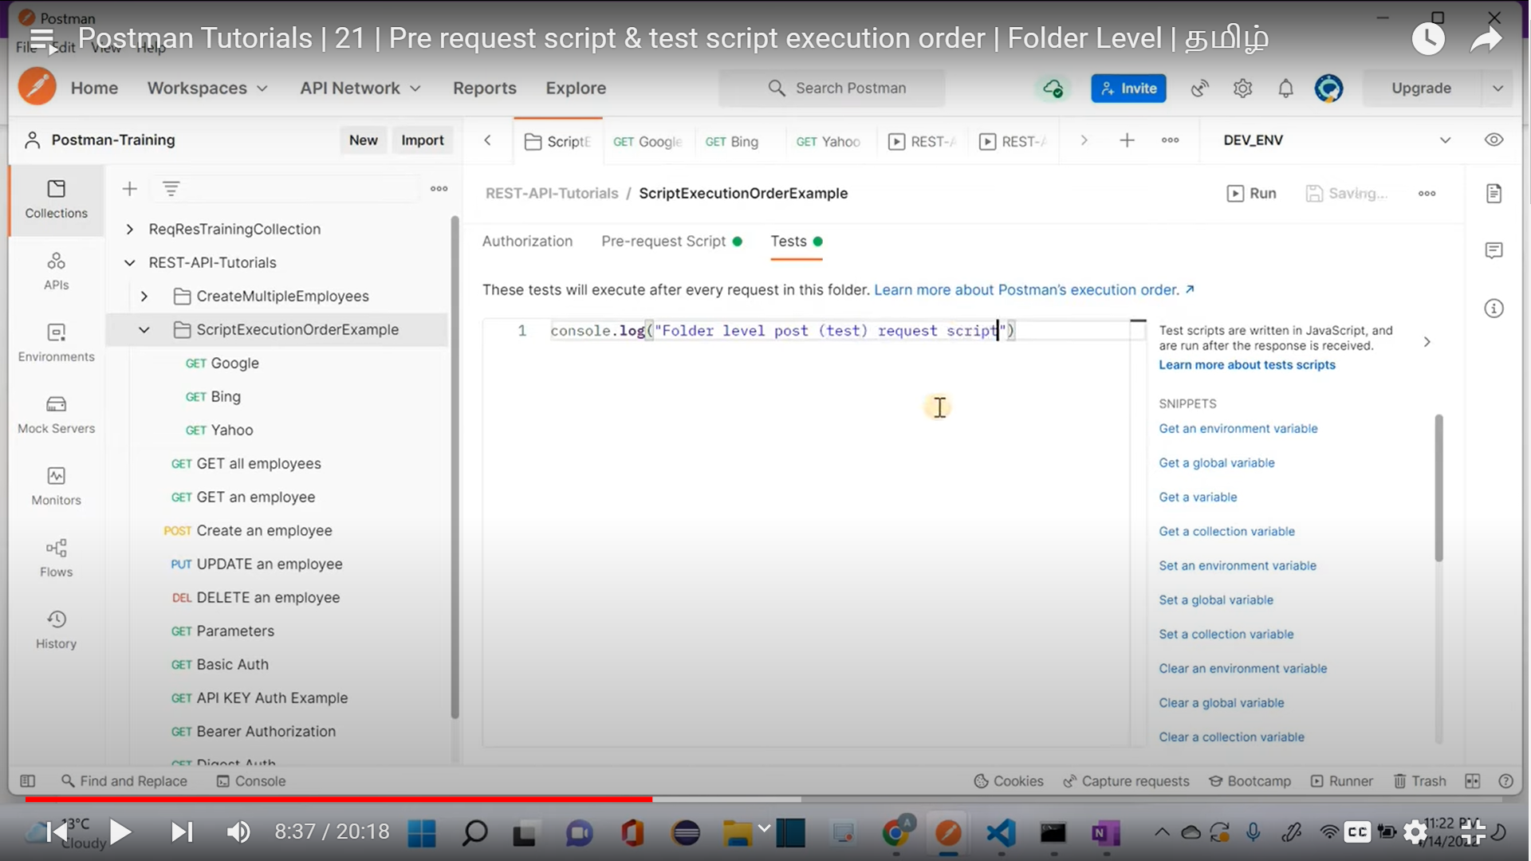

**After Execution**

Folder level Pre-request script

Request level pre-request script

Actual Request

Folder level Test script (Folder level post-request script)

Request level Test script (Request level post-request script)

Note: Incase If we have collection level pre-request script and test script then execution order will be

Collection pre-request🡪

Folder pre-request🡪

Actual request 🡪

collection post request (Test)script🡪

Folder post request (Test) script🡪

Request level Test script

**Request Chaining🡪**

In simple words, Request chaining is a process of passing the output of first request as a input value to the second request

First Request🡪 Response (output)🡪Second request (taking previous output as an input)

**1st Request🡪**

Response

Store this response into a json object and get any one unique key

Create a collection/global/env variable and store this key

**2nd Request🡪** pass the collection variable in the request

Different ways to create a variable for json body

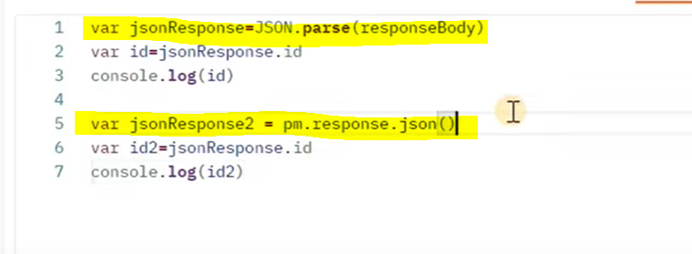

Json path

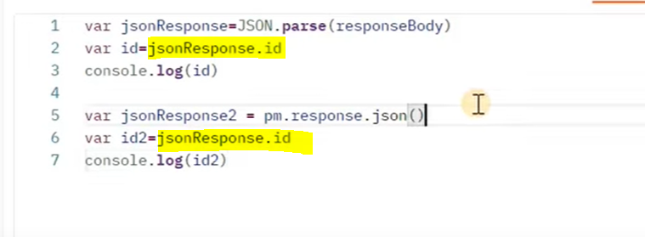

Create a collection variable

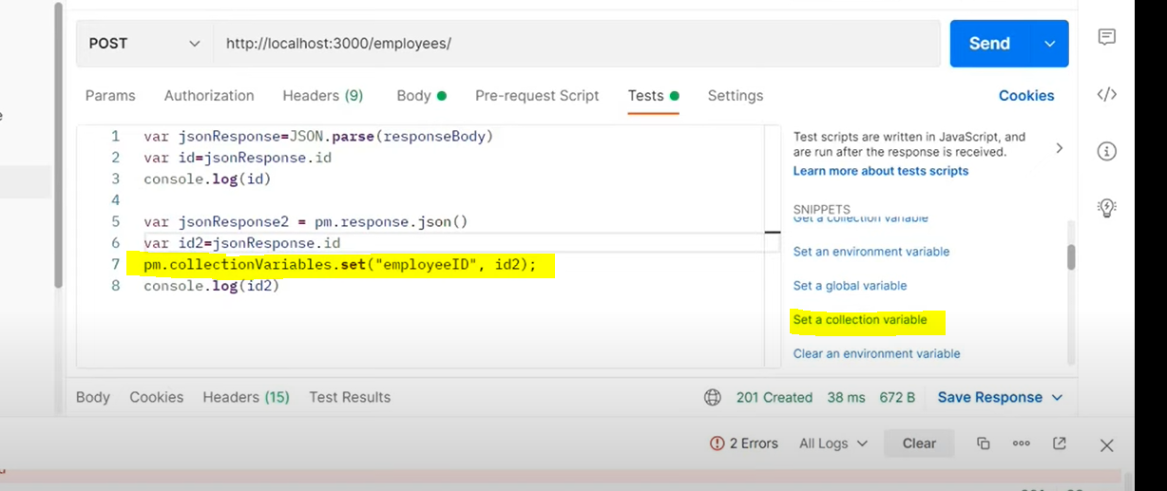

Passing the collection variable into the next request

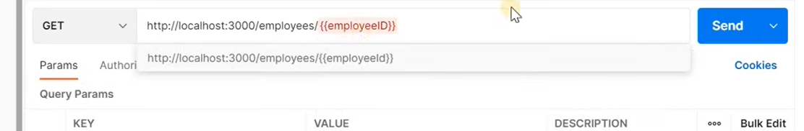

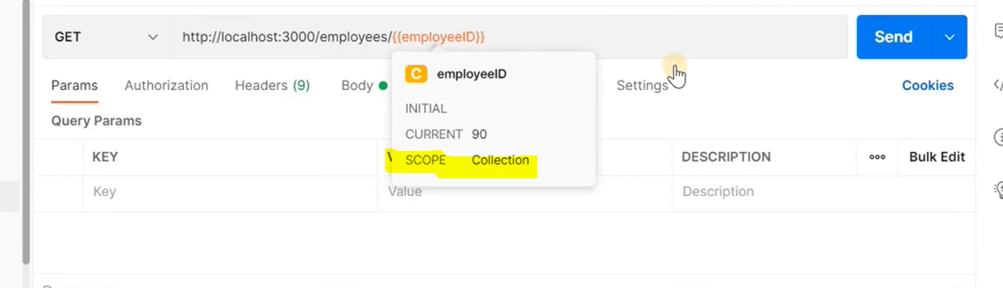

Both Requests are executed successfully (Request chaining achieved)

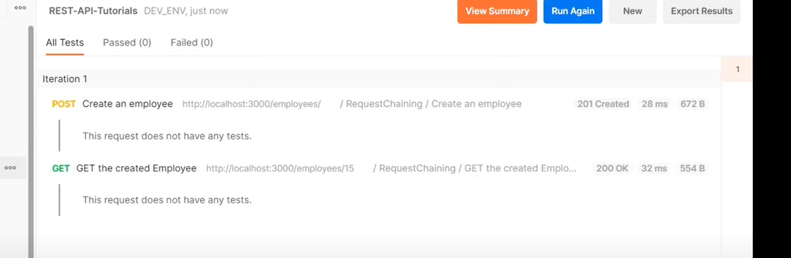

**Different ways to Run Collections**

1.Directly click on Run

If we run a collection, then requests will be executed in given order

Folders will be running first based on the given order and then individual requests will be running

And we can re-arrange the order as we need

We can also export the results

2.Running Collection through Monitors

(Note: In Background monitor using the web hook)

We must select the collection which needs to be run

We can configure the environment

We can also setup the Running frequency

Create Monitor

Using Monitor summary, we can see the progress

**WORKFLOWS**

Achieved using postman.setNextRequest()

Based on the place where it is used it will be applicable only that region

For E.g. If it is used in collection, then only within collection /or only within folders

We can either provide the Request Name or Request ID

With Request Name🡪

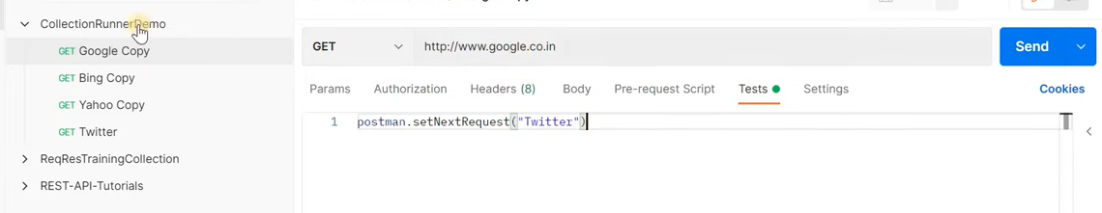

With Request ID🡪

To get the request ID click on the request and then click on the info button

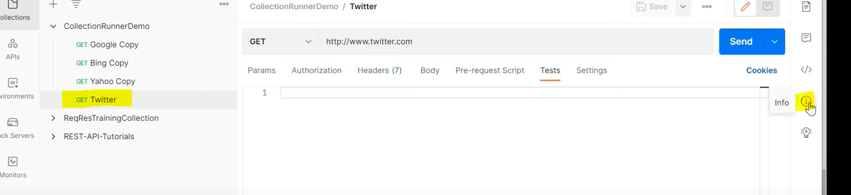

Copy the ID

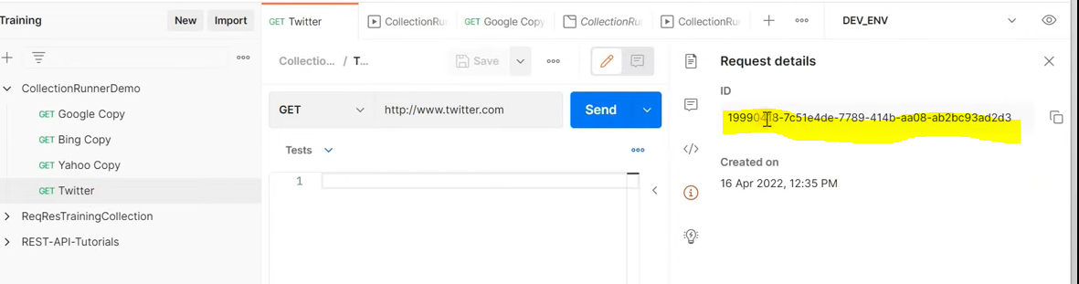

But this ID is a combination of User ID + Request ID, so we should remove the first 8 digits and then use it workflow setup

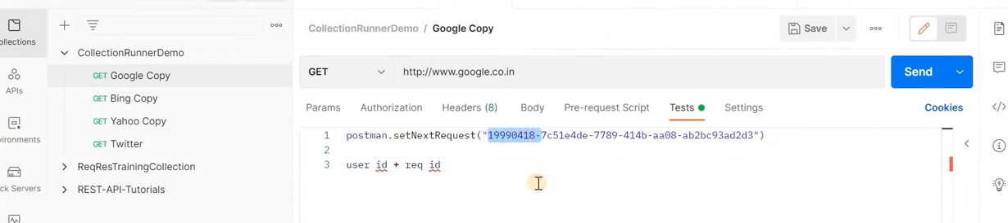

Correct Request ID

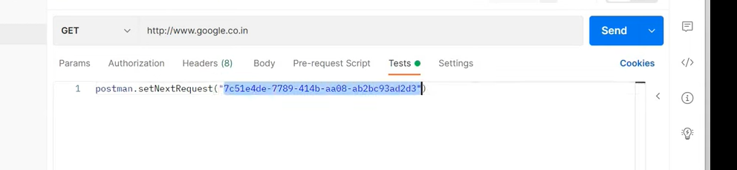

Important conditions

1.Eventhough we have postman.setNextRequest() in the pre-request script this will not be executed because if system re-directed as per the pre-request script, then current execution is not going to happen

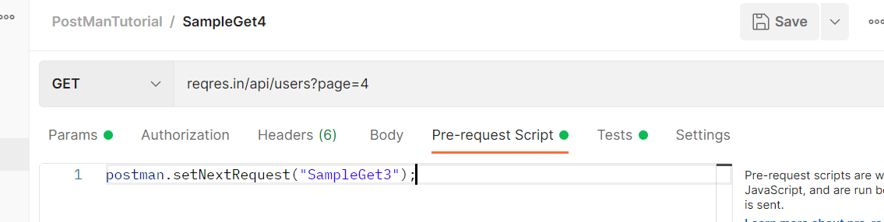

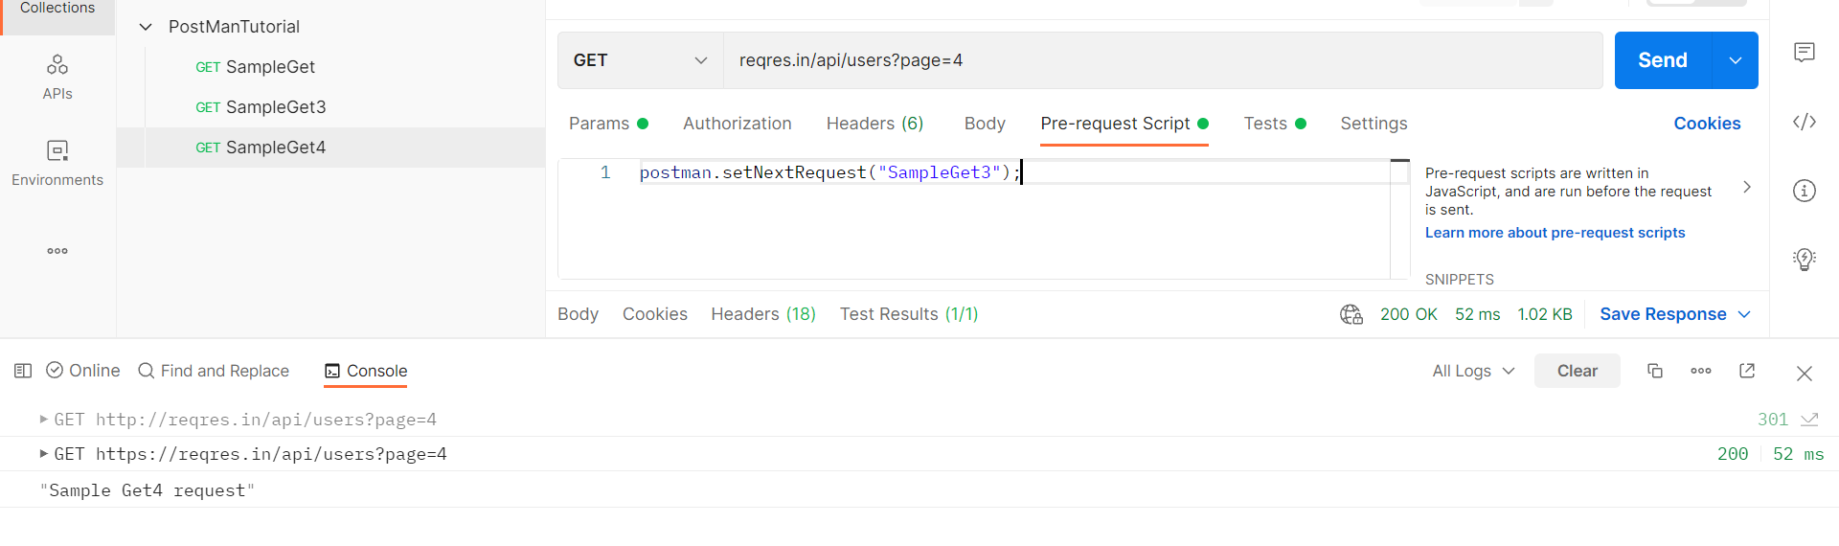

2.Incase if we have postman.setNextRequest() in the pre-request script and Test script then, only the script which is present under Test will be executed and navigation will happen accordingly.

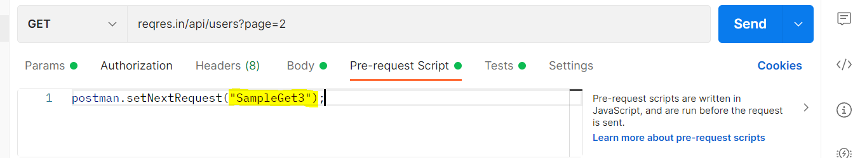

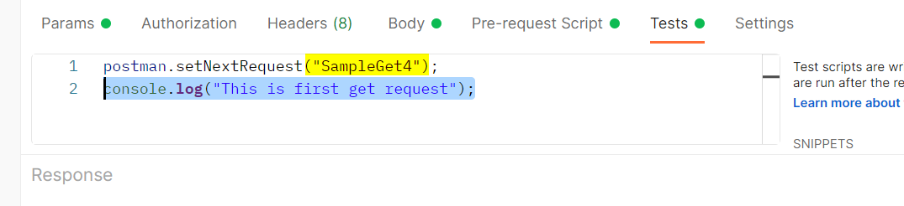

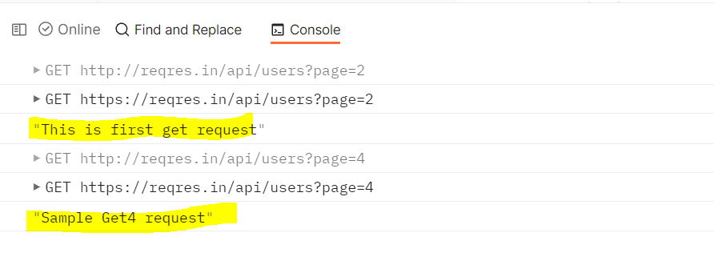

3.In case we have validations for current execution and postman.setNextRequest() in test tab in this case current validations will be executed first and then navigation will happen. Because if navigation happened first then the validations are not going to happen

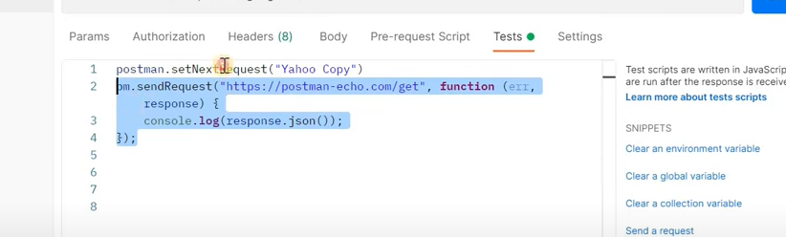

4.We should not give postman.setNextRequest() to form an infinite loop. So always be cautious while setting the flow.

E.g.

In A Request🡪B should start After A

In B Request 🡪 A should start After B

**New Man 🡪Command line interface for postman**

**The major use of CLI is for Jenkins integration**

**npm Install -g newman**

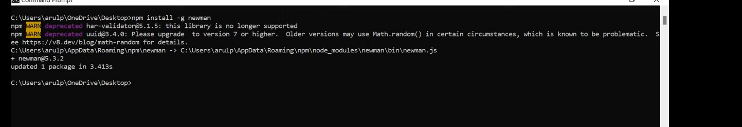

To run a collection from Newman, follow the below steps

1.Export the collection

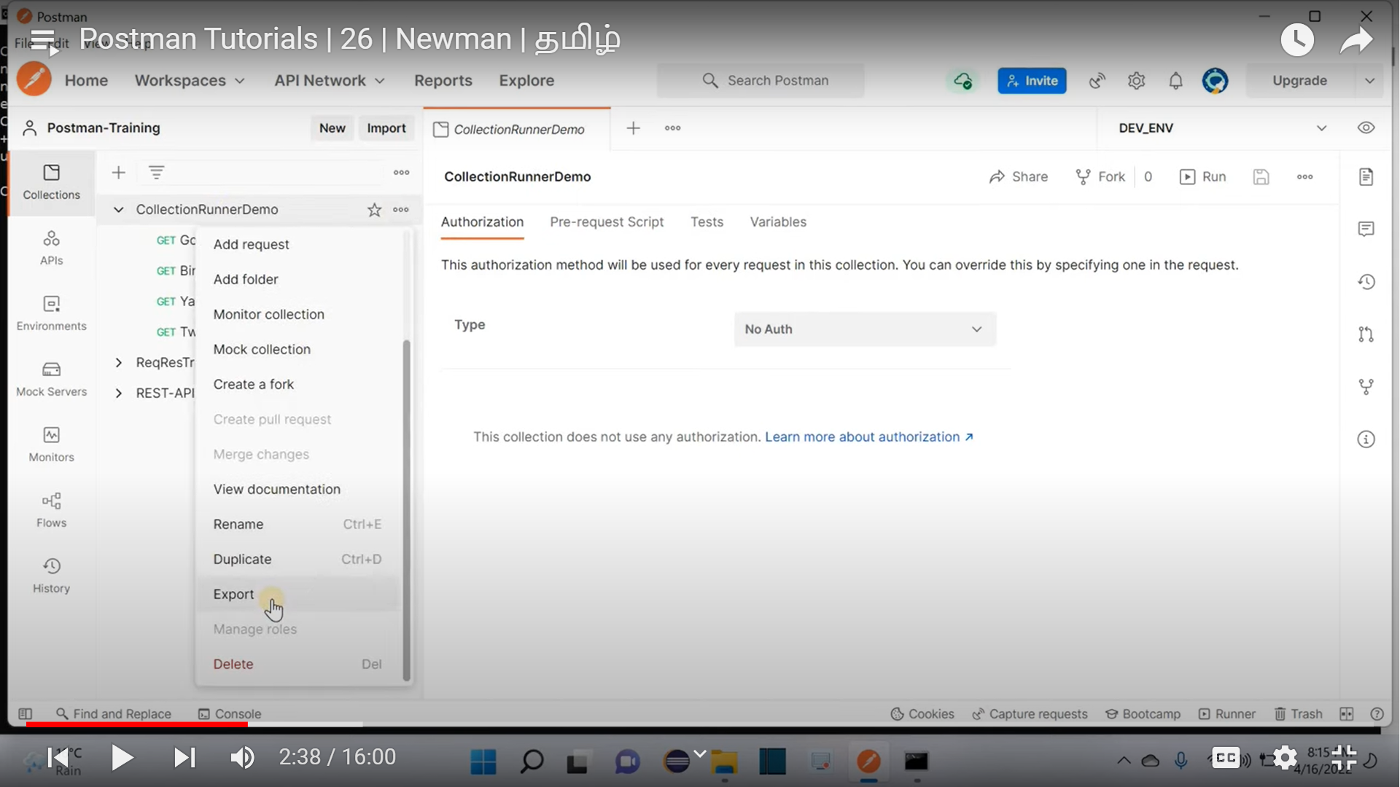

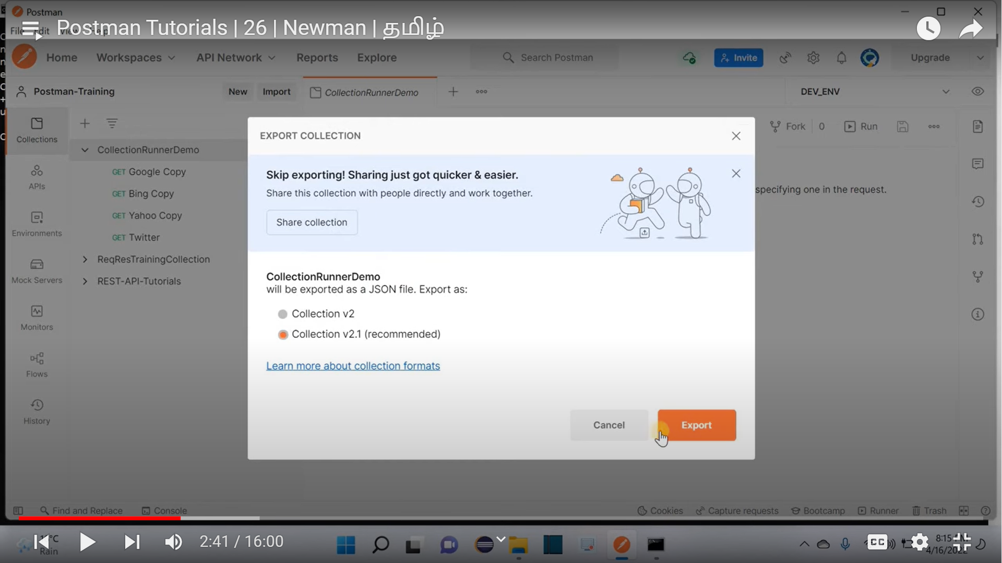

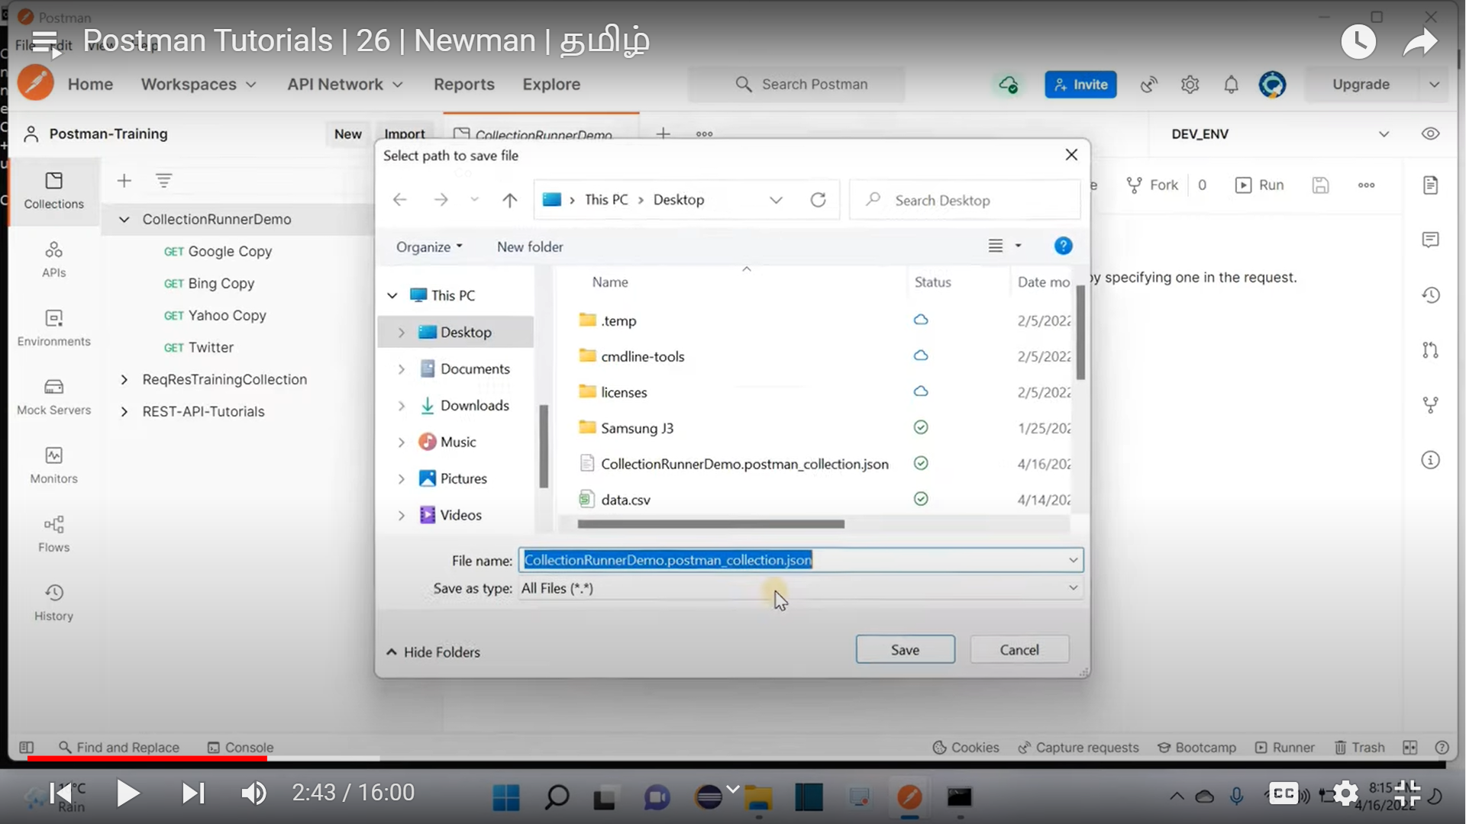

newman run “**exported collection name**”

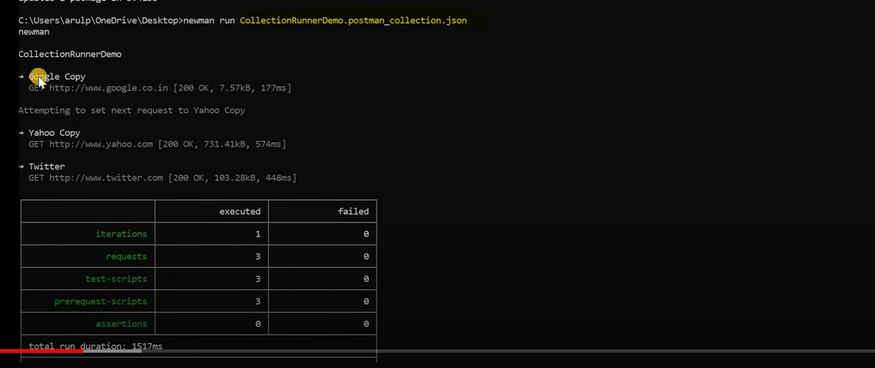

**Share collection**

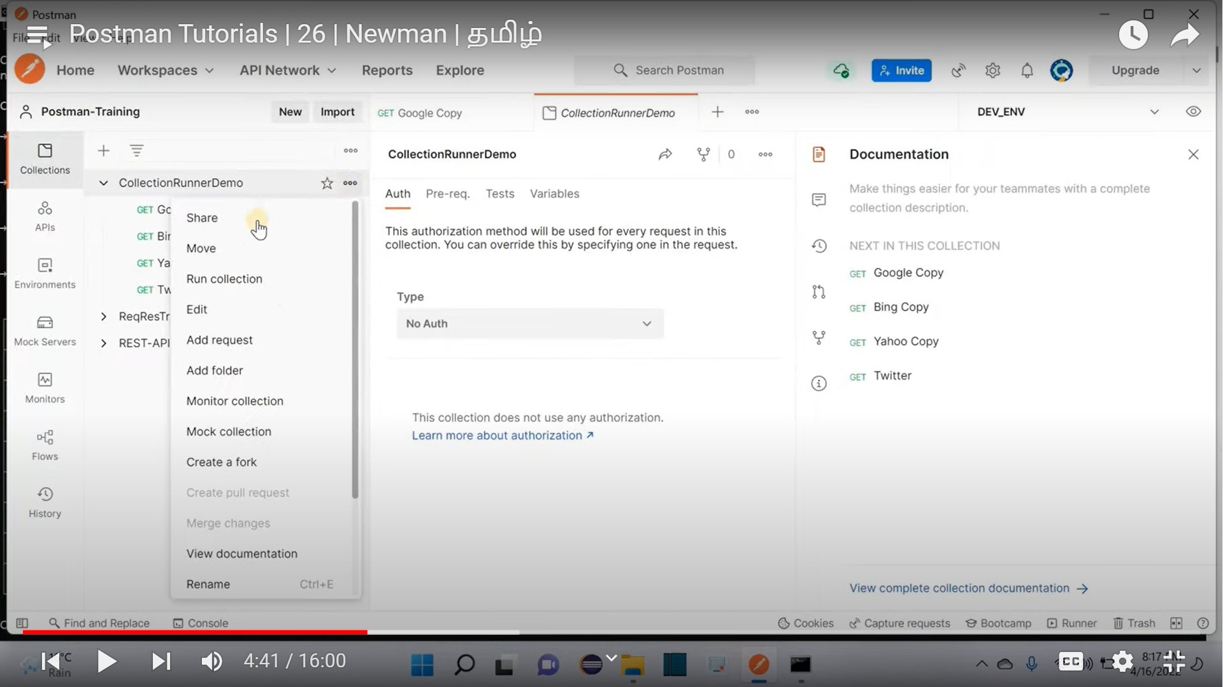

**Via JSON link**

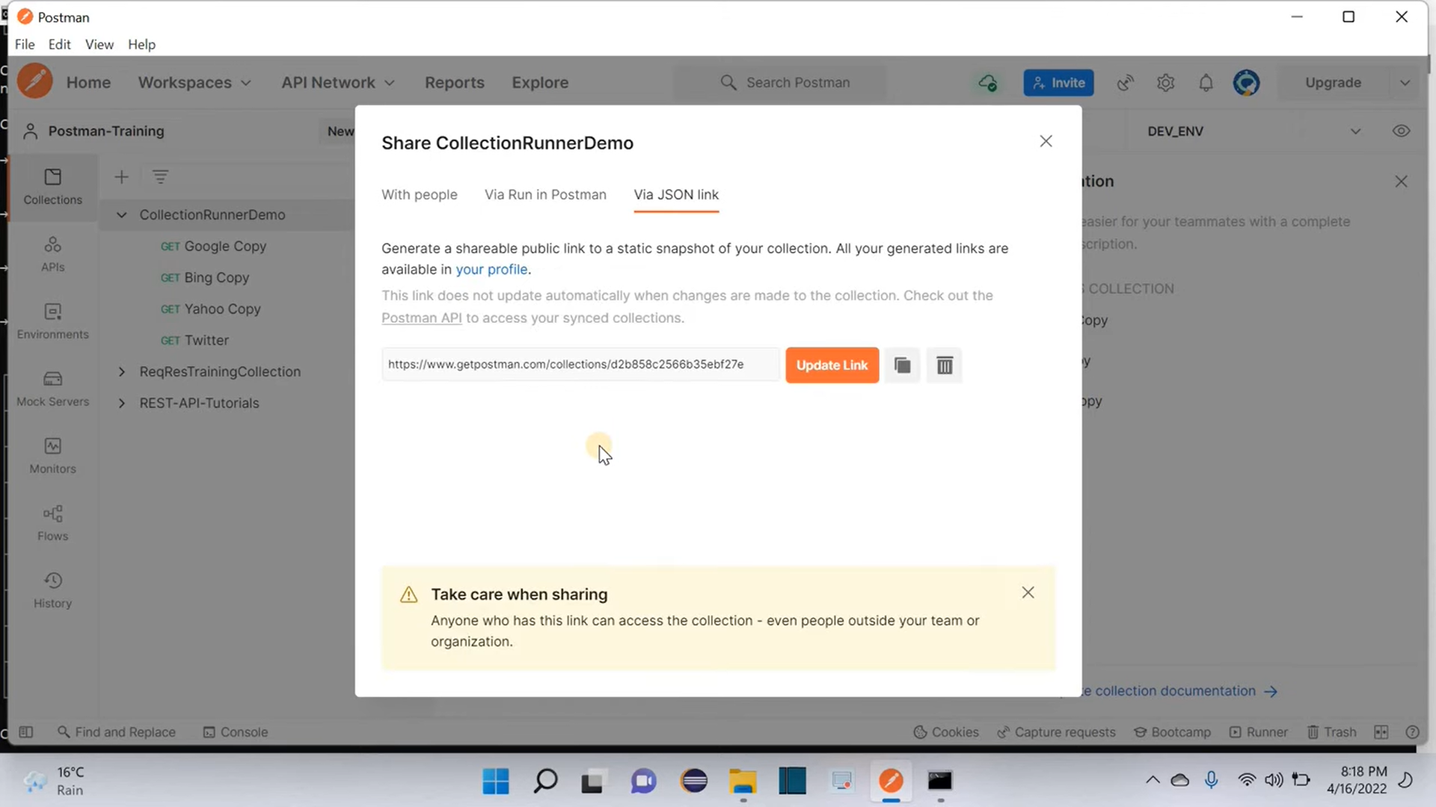

**newman run “collection link”(share)**

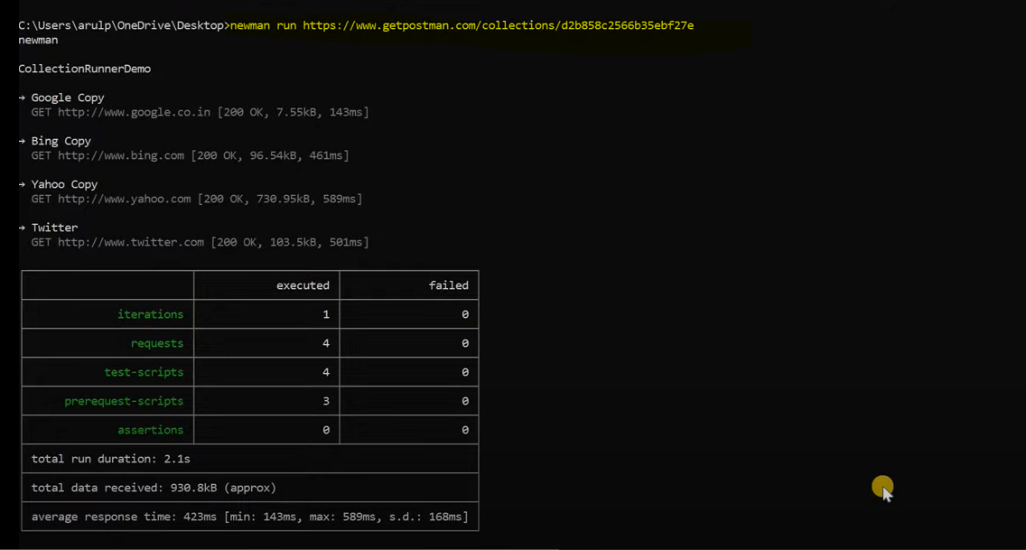

**Running a collection multiple time**

**Newman run name/link -n number**

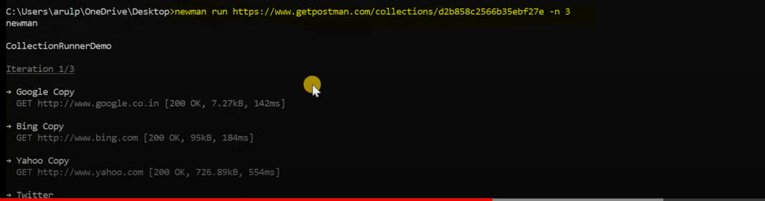

**To run the collection from new man by using Data driven concept**

**Newman run name/link -d data file name**

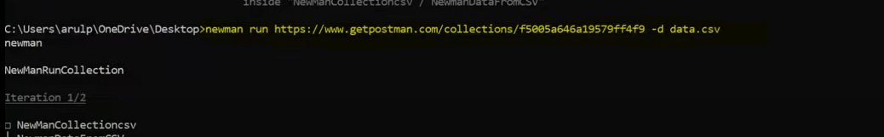

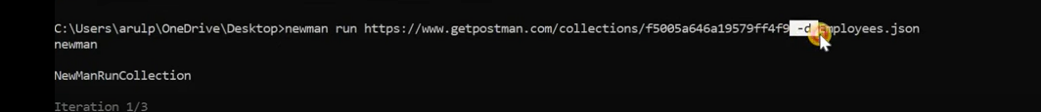

**To Run any specific folder within the collection**

**Newman run name/link -d data file name –folder folder name**



**To Run Requests through newman with Environment variables in place**

**newman run name/link -e exported env variable file**

**Edit**

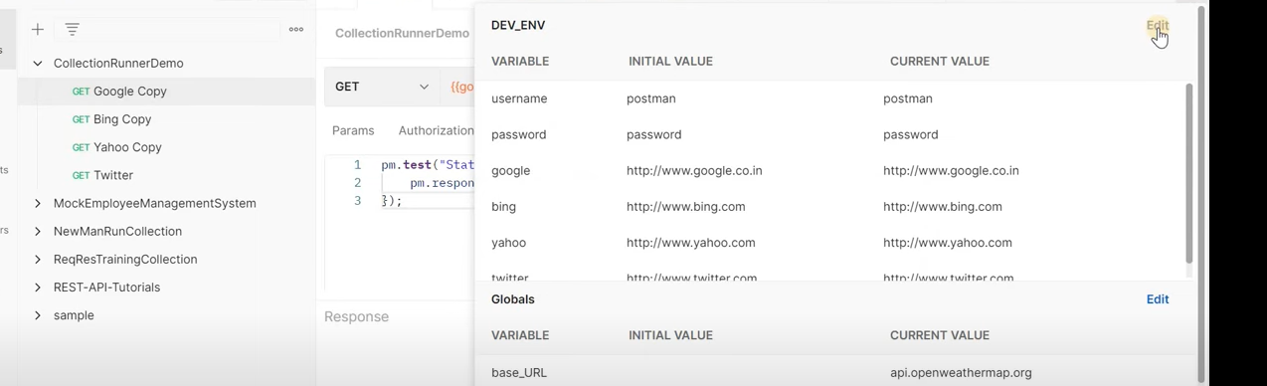

**Export**

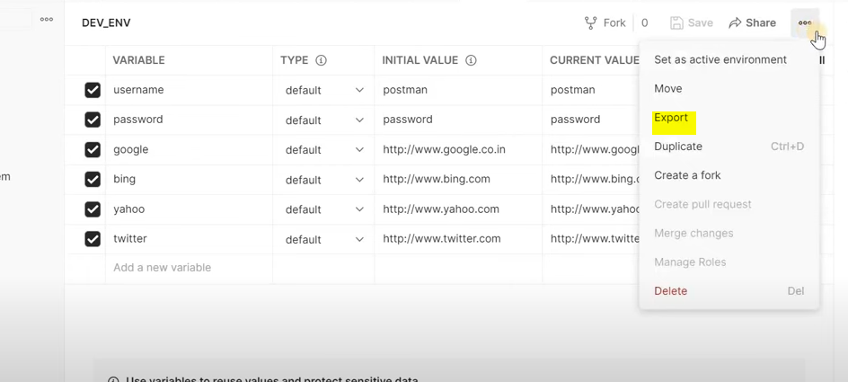

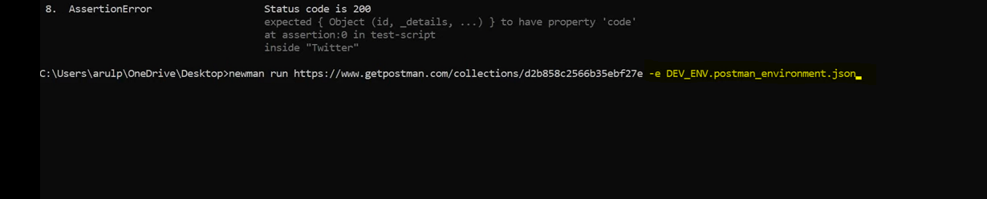

Note: We can’t do flows in newman, apart from that we can do everything that we are doing in UI

Special Thanks to Arul prasad Ranganathan: <https://www.youtube.com/c/LearnAutomationOnline>